Introduction

Each and every organization which has either implemented Oracle HCM Cloud or is planning to do so would definitely have one or more multiple HCM Extracts being used.

In some cases, these extracts take a pretty long time and we would like to know which specific activity within the process is consuming more time and if there is a way to improve the performance of the overall extract.

While one can always raise a Service Request to get these details, but one also has a self-service available. This self-service option is “***Extracts Process Diagnostic Report***”.

“***Extracts Process Diagnostic Report***” is a delivered Scheduled Process which can be run from Tools -> Scheduled Processes. It takes Extract Flow Instance name as an input (you choose from a list of available drop-down options) and gives details about the various activities which were performed and the time each activity took.

We would try to run the process for one extract flow instance and understand the same better.

Worked-Out Example

We would login to the application with a user having admin privileges and navigate to

Tools->Scheduled Processes-> Choose (***Extracts Process Diagnostic Report*** and then a existing Extract instance flow (BO01 for this example) and submit the process as shown in screenshot below:

The process will generate one log and one output file and when we open the output file it would look as below:

Scrolling down a bit more and we would see details like Total No of Records Processed, Total No of Records Completed, Total No of Records Skipped, Total No of Records Unprocessed and Total Number of Records Errored. There is also a “Overall Timing Summary” section which provides details about each step and time taken by the process.

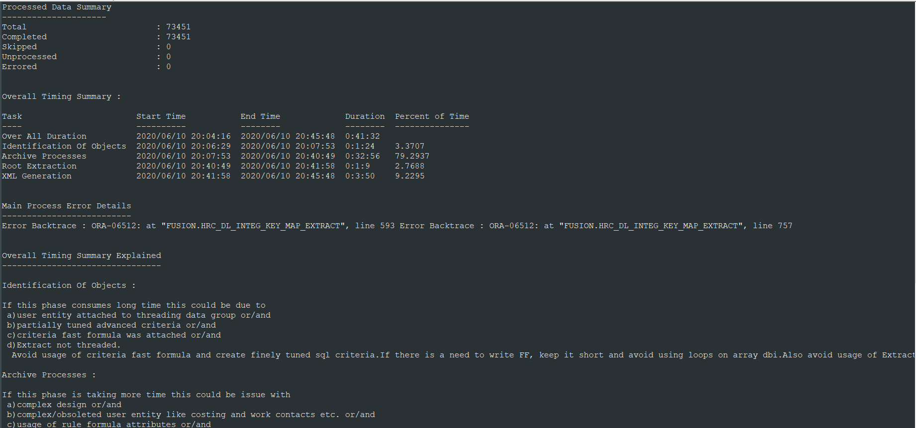

In addition to all these details the process also provides the “Best practice guidelines” which one should follow while designing the Extract to get optimal performance.

Summary

So this is one smart and easy way to get diagnostic details of long running HCM Extracts. One can run this diagnostic scheduled process and get insight about the intricate details of a particular extract flow instance.

And with this , I have come to end of my article.

Hope this was a good read.

Thanks all for your time , have a great day ahead.